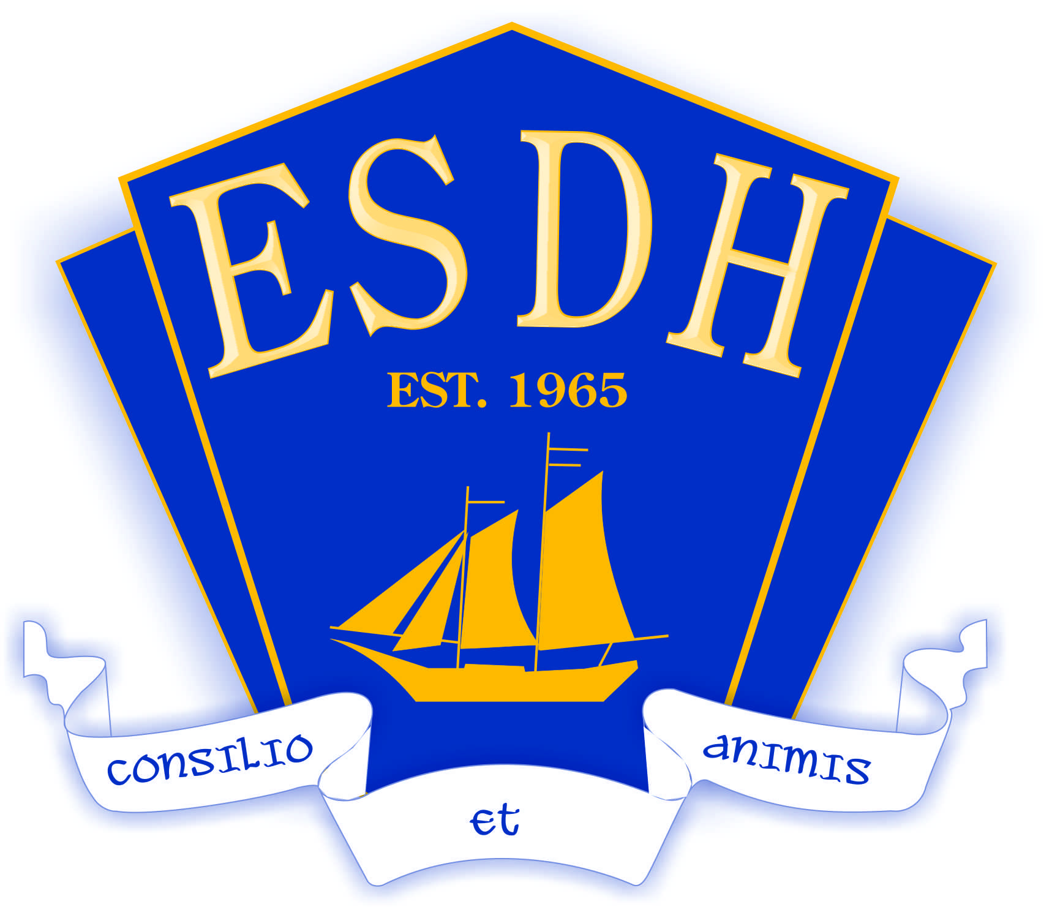

Consent and Release: Student to be Filmed/Photographed for Use of Image/Voice

I,[Parent/Guardian____________], hereby grant to Halifax Regional Center for Education, their successors, and their assignees the right to record the image and/or voice and use the artwork and/or written work of my child, [Student Name__________], on videotape, on film, on photographs, in digital media and in any other form of electronic or print medium and to edit such recording at their discretion.

I understand that my child’s full name, address and biographical information will not be made public. I further grant Halifax Regional Center for Education, their successors, and their assignees the right to use, and to allow others to use, my child’s image and/or voice on the internet, in brochures, and in any other medium and hereby consent to such use.

I hereby release Halifax Regional Center for Education, their successors, and their assignees and any using my child’s image and/or voice, artwork, and/or written work pursuant to this media release form any and all claims, damages, liabilities, costs and expenses which I or my child now have or may hereafter have by reason of any use thereof. I understand that the provisions of this release are legally binding.
Please check one:

I consent. I do not consent.

Print Name of Parent/Guardian: _________________________________________

Parent/Guardian Signature: ____________________________________________

Date: ___________________________________________________________

Student’ Name: ____________________________________________________

